  Institute of Geodesy  and Geoinformatics  Wroclaw University  of Environmental and Life Sciences |   Institute of Rock Structure  and Mechanics  of the Academy of Sciences  of the Czech Republic
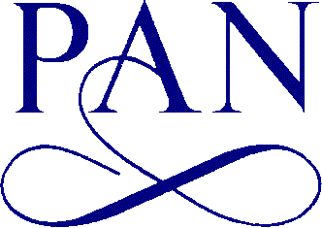  Section of the Geodynamics  Committee of Geodesy  Polish Academy of Sciences | 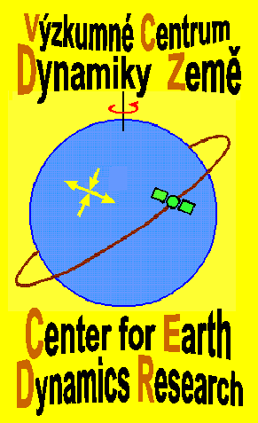

SECOND CIRCULAR
8TH CZECH-POLISH WORKSHOP
ON RECENT GEODYNAMICS
OF THE SUDETEN
AND ADJACENT AREAS

Kłodzko, Poland
March 29-31, 2007

WORKSHOP scheduled PROGRAMME

Thursday —March 29th, 2007

Registration 10:00 – 13:00
Lunch 13:00 – 14:00
Opening ceremony 14:00 – 14:30
Session Nº 1 14:30 – 16:00
Coffee break 16:00 – 16:30
Session Nº 2 16:30 – 18:00
Coffee break 18:00 – 18:15
Session Nº 3 18:15 – 19:15
Dinner 19:45 – 20:30

Friday — March 30th, 2007

Breakfast 7:30 – 08:30
Session Nº 4 08:30 – 10:00
Coffee break 10:00 – 10:30
Session Nº 5 10:30 – 12:00
Coffee break 12:00 – 12:15
Session Nº 6 12:15 – 13:15
Lunch 13:30 – 14:30
Session Nº 7 15:00 – 16:30
Coffee break 16:30 – 17:00
Session Nº 8 17:00 – 18:30
Dinner – Get-together party 19:00 – 22:00

Saturday — March 31th, 2007

Breakfast 7:30 – 08:30
Field session (Złoty Stok – Kłodzko) 8:30 – 13:00
Lunch 13:00 – 14:00
Discussion and Closing Ceremony 14:00 – 15:00

PRESENTATION TIME LIMIT
Maximum 15 minutes for one paper (including discussion).

OFFERED EQUIPMENT
- PC
- Overhead projector
- Multimedia projector

OFFICIAL LANGUAGES
The official languages of lectures of the Workshop will be English, Czech, Polish and Slovak. The abstract book and papers will be in English.

Field session
Attention! Considering the variable and unexpectedly changed weather the participants should be tourist equipped.

LOCAL ORGANIZING COMMITTEE (LOC):
Dr. Habil. Bernard Kontny, Prof. WUELS ¹⁾ Chairman
RNDr. Vladimír Schenk Dr. Sc²⁾ Vice Chairman
Dr. Olgierd Jamroz¹⁾ Secretary
Prof. Dr. Stefan Cacoń ¹⁾
Dr. Habil. Jarosław Bosy¹⁾
RNDr. Zdeňka Schenková CSc²⁾
RNDr. Frantisek Mantlik ²⁾

1) Institute of Geodesy and Geoinformatics of the Wroclaw University of Environmental and Life Sciences
2) Institute of Rock Structure and Mechanics, Academy of Science of the Czech Republic, Prague

Address and contact persons
8th Czech-Polish Workshop
Wrocław University of Environmental and Life Sciences
Institute of Geodesy and Geoinformatics
Grunwaldzka 53
50-357 Wrocław, Poland
Phone/Fax +48 71 3205617
Phone: +48 71 3201953 (Dr. O. Jamroz)
E-mail: jamroz@kgf.ar.wroc.pl

ACCOMMODATION
The Workshop will take place at the Hotel METRO in Boguszyn near Kłodzko. It is the new hotel, opened in 2005, conveniently situated in the centre of Kłodzko Valley, close to International road No 8 (E-67) Wroclaw – Prague - Vienna, 2 km from Kłodzko, 80 km from Wroclaw, 30 km from Kudowa Zdroj. Web page of the hotel: http://hotelmetro.pl/

WWW PAGES
See more infoon the Workshop’s WWW pages:
http://www.geo.ar.wroc.pl/8workshop/8workshop.html

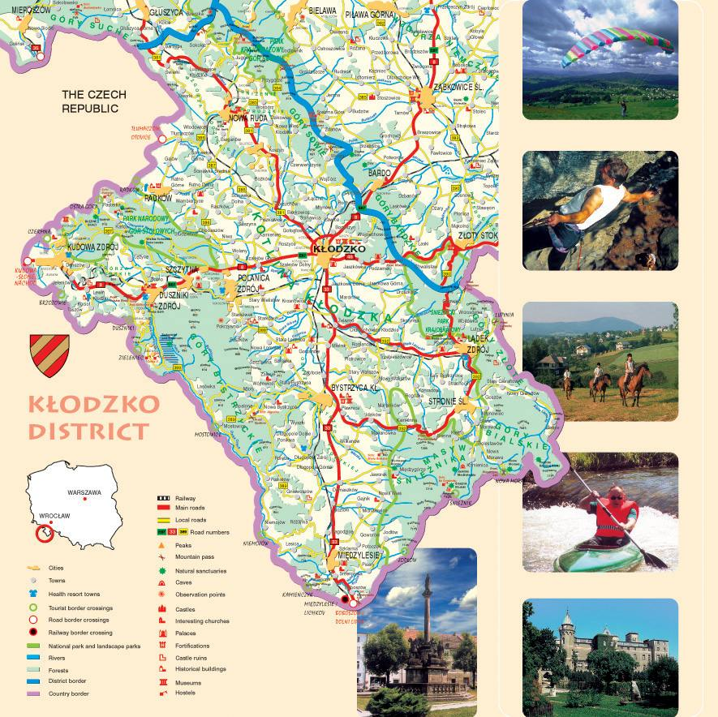
MEETING PLACE -> O

