  Department of Geodesy  and Photogrammetry  Agricultural University  of Wrocław, Poland | 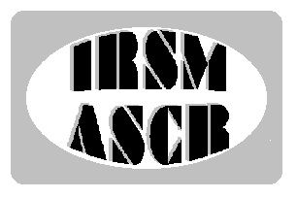  Institute of Rock Structure  and Mechanics  of the Academy of Sciences  of the Czech Republic
Section of the Geodynamics  Committee of Geodesy  Polish Academy of Sciences | 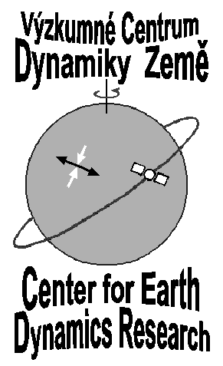

SECOND CIRCULAR

6TH CZECH–POLISH WORKSHOP
ON RECENT GEODYNAMICS
OF THE SUDETY MTS.
AND ADJACENT AREAS

Łężyce, Poland
November 4-6, 2004

WORKSHOP scheduled PROGRAMME

Thursday — November 4th, 2004

Lunch 12:30 – 13:30
Opening ceremony 14:00 – 14:30
Session Nº 1 14:30 – 16:00
Coffee break 16:00 – 16:30
Session Nº 2 16:30 – 18:00
Discussion Nº 1 18:00 – 18:30
„Get–together” party 19:00

Friday — November 5th, 2004

Breakfast 7:00 – 08:00
Field sessions 8:00 – 15:00
- Duszniki Zdrój, Wambierzyce 8:00 – 11:00
- Szczeliniec 11:00 – 14:00
Come back to Łężyce 15:00
Lunch 15:00 – 16:00
Session Nº 3 16:00 – 17:15
Coffee break 17:15 – 17:45
Session Nº 4 17:45 – 18:45
Discussion Nº 2 18:45 – 19:15
Barbecue 19:30

Saturday — November 6th, 2004

Breakfast 8:00 – 09:00
Session Nº 5 9:00 – 10:30
Coffee break 10:30 – 11:00
Session Nº 6 11:00 – 12:15
Discussion Nº 3 12:15 – 12:45
Closing ceremony 12:45 – 13:00
Lunch 13:00 – 14:00

PRESENTATION TIME LIMIT
Maximum 15 minutes for one paper (including discussion).

OFFERED EQUIPMENT
- Overhead projector
- Slide projector
- LCD projector for computer presentations

OFFICIAL LANGUAGES
The official languages of lectures of the Workshop will be English, Czech, Polish and Slovak. The abstract book and papers will be in English.

Field sessions
Attention! Considering the variable and unexpectedly changed weather the participants should be tourist equipped.

ORGANIZING COMMITTEE
Prof. Dr. Stefan Cacoń¹⁾ Chairman
RNDr. Vladimír Schenk Dr. Sc²⁾ Vice Chairman
Dr. Olgierd Jamroz¹⁾ Secretary
RNDr. Zdeňka Schenková CSc²⁾
Dr. Jarosław Bosy¹⁾
Dr. Bernard Kontny¹⁾
Ing. Pavel Kottnauer²⁾

1) Department of Geodesy and Photogrammetry, Agricultural University of Wrocław
2) Institute of Rock Structure and Mechanics, Academy of Science of the Czech Republic, Prague

Address and contact persons
6th Czech–Polish Workshop
Agricultural University of Wrocław
Department of Geodesy and Photogrammetry
ul. Grunwaldzka 53
50-357 Wrocław, Poland
tel/fax: +48-71-3205617

Dr. Olgierd Jamroz: jamroz@kgf.ar.wroc.pl

ACCOMMODATION
Accommodation for all participants of the Workshop will be arranged in a small hotel “U ANNY” in Łężyce near Duszniki Zdrój. The hotel offers 105 places in 2-, 3- and
4-person rooms, coffee room, TV room, dining room,
snooker and a lecture room.
http://www.gory.info.pl/u_anny/index.html
http://www.uanny.com.pl.

WWW PAGES
See more infoon the Workshop’s WWW pages:
http://www.geo.ar.wroc.pl/6workshop/6workshop.html

